ONEWAY PREC BY WOKE
/STATISTICS DESCRIPTIVES HOMOGENEITY WELCH
/PLOT MEANS
/MISSING ANALYSIS.

Oneway

Notes
Output Created |  | 05-May-2019 23:45:27
Comments
Input | Active Dataset | DataSet0
Input | Filter | <none>
Input | Weight | <none>
Input | Split File | <none>
Input | N of Rows in Working Data File | 30
Missing Value Handling | Definition of Missing | User-defined missing values are treated as missing.
Missing Value Handling | Cases Used | Statistics for each analysis are based on cases with no missing data for any variable in the analysis.
Syntax |  | ONEWAY PREC BY WOKE  /STATISTICS DESCRIPTIVES HOMOGENEITY WELCH  /PLOT MEANS  /MISSING ANALYSIS.
Resources | Processor Time | 00 00:00:00.156
Resources | Elapsed Time | 00 00:00:00.153

[DataSet0]

Descriptives
 | N | Mean | Std. Deviation | Std. Error
Between 1-4 hours | 5 | 68.0000 | 34.02205 | 15.21512
Between 4-6 hours | 9 | 26.6667 | 19.84313 | 6.61438
Between than 6-8 hours | 3 | 68.3333 | 56.19905 | 32.44654
More than 8 hours | 13 | 42.3077 | 37.61734 | 10.43317
Total | 30 | 44.5000 | 36.42067 | 6.64947

Descriptives
 | 95% Confidence Interval for Mean |  | Minimum | Maximum
 | Lower Bound | Upper Bound | Minimum | Maximum
Between 1-4 hours | 25.7560 | 110.2440 | 30.00 | 120.00
Between 4-6 hours | 11.4139 | 41.9195 | 5.00 | 60.00
Between than 6-8 hours | -71.2728 | 207.9395 | 20.00 | 130.00
More than 8 hours | 19.5758 | 65.0396 | .00 | 125.00
Total | 30.9003 | 58.0997 | .00 | 130.00

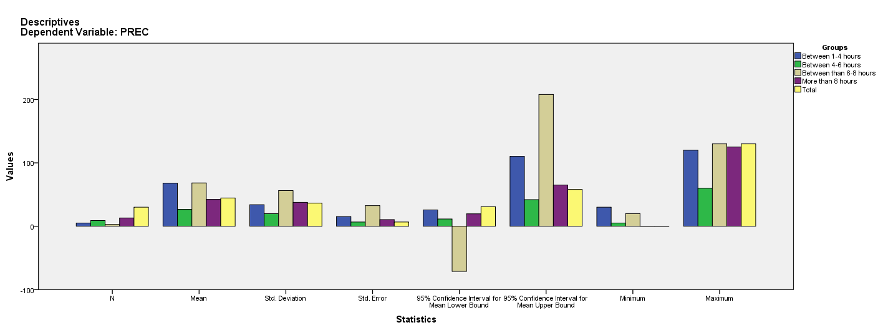

Test of Homogeneity of Variances
PREC
Levene Statistic | df1 | df2 | Sig.
1.605 | 3 | 26 | .212

ANOVA
PREC
 | Sum of Squares | df | Mean Square | F | Sig.
Between Groups | 7390.064 | 3 | 2463.355 | 2.061 | .130
Within Groups | 31077.436 | 26 | 1195.286
Total | 38467.500 | 29

Robust Tests of Equality of Means
PREC
 | Statisticª | df1 | df2 | Sig.
Welch | 2.164 | 3 | 6.789 | .183
a. Asymptotically F distributed.

Means Plots

